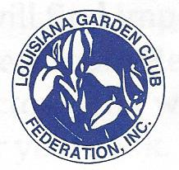

LGCF Award Application Cover Sheet (revised August 2022)

Award Number______________ Award Name ____________________________________________________________

Name of Club Applying for Award

_______________________________________________________________________________ District ___________

Number of members_________________________ Award Size Group __________ S_________ M_________ L

Contact Name ____________________________________________________ _________________________________

Email____________________________________________________ Phone ____________________________

Address ____________________________________________________________________________________

____________________________________________________________________________________
City Zip

Is this project ________ New OR ________ Continuing from previous work?

Beginning date: ________________ Expected completion date: __________________ OR ____________Ongoing

Please complete each topic, if applicable on separate sheets. Use numbering as below when completing form.
1. Brief summary and objectives of project
2. Involvement of club members, other organizations, etc.:
3. Project expenses and means of funding:
4. Continuing involvement, follow-up, maintenance:
5. Attach or insert photos, digital photos, and/or landscape plan (does not need to be professionally drawn).

ATTACH completed application. Unless noted in specific award description, all applications are limited to 3 single sided pages. (Plus this cover sheet). No report covers, notebooks, etc. allowed.

AWARD APPLICATION SUGGESTION:
1) PRINT FORM
2) Complete form and use as a cover sheet only. ANSWER QUESTIONS 1 THRU 5 using the fronts of three additional pages for a total of four pages.
3) Mail to proper awards chairman found in ﻿General Rules & List of Awards.﻿

