Lafayette Garden Club
Deeds and Doings April 2023
LGC April 2023 Garden of the Month Award
The Lafayette Garden Club is pleased to award the April Garden of The Month to Wendy and Will McCombie located at 500 Montrose Drive in Lafayette, La. Wendy and Will purchased the home about 3 years ago and planted every single tree, shrub, and annual themselves. They enjoy gardening and it shows the yard is gorgeous. The yard is beautifully landscaped, and the lovely porch is so inviting. The front porch is highlighted by Sweet Bay Magnolias, Sweet Olive, Camellias, Knock Out Roses, Fox Tail Ferns, and Chinese Fringe Shrubs. Last year Wendy and Will planted 22 flats of Panola annuals and are getting to do the same for the summer. The lawn is lush and green, Will loves to mow and it shows.
Thank you so much Wendy and Will for loving gardening and keeping Lafayette a beautiful city to live. Treat yourself and drive by this beautifully landscaped yard and home.
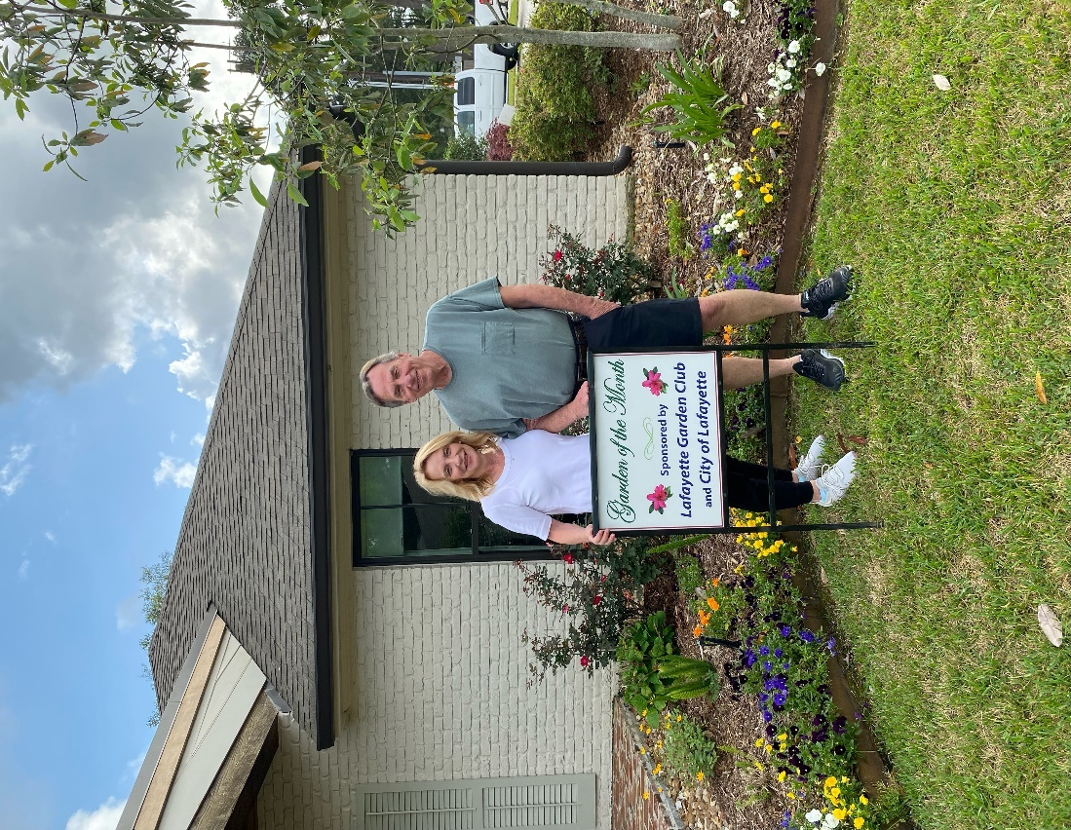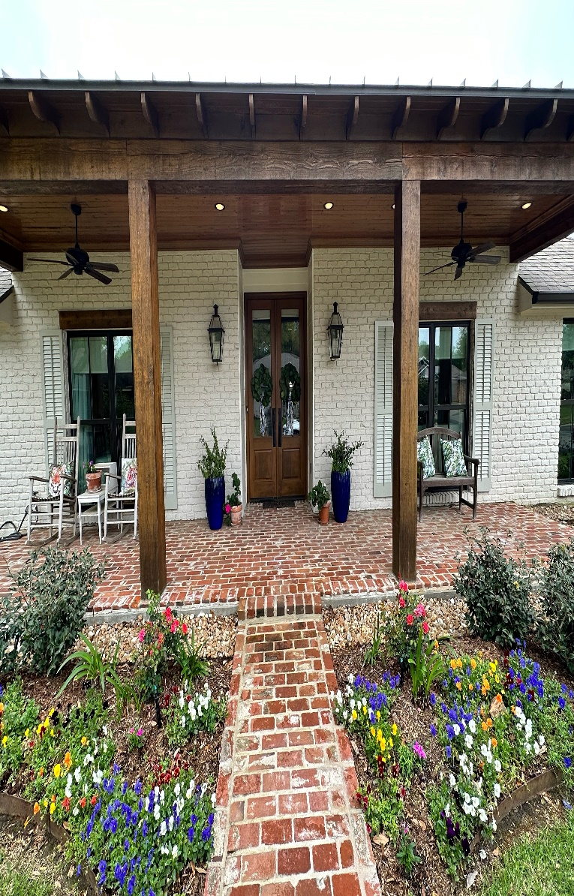
Lafayette Garden Club is a member of District III, Louisiana Garden Club Federation, Inc, Deep South Garden Clubs, Inc, and the National Garden Club Federation, Inc.

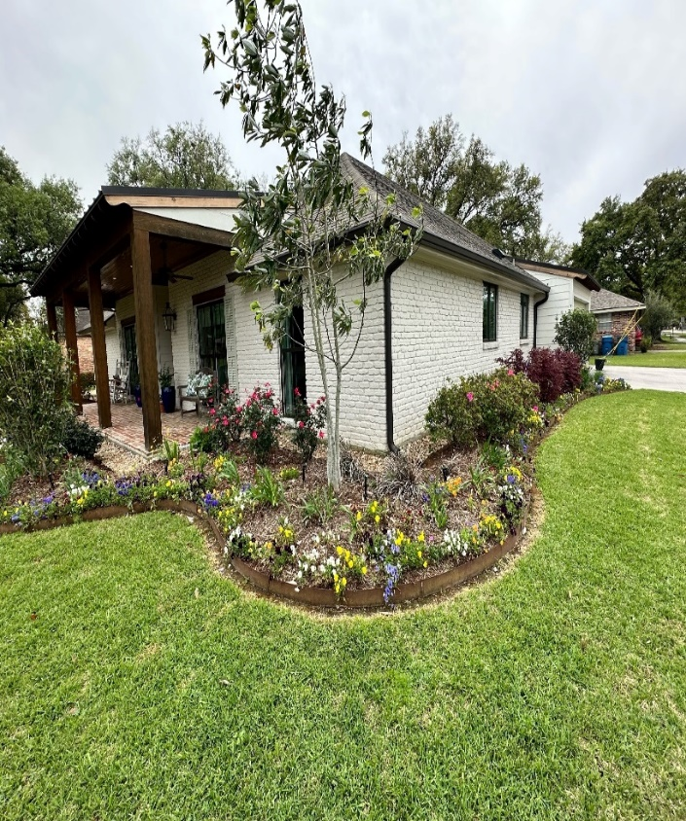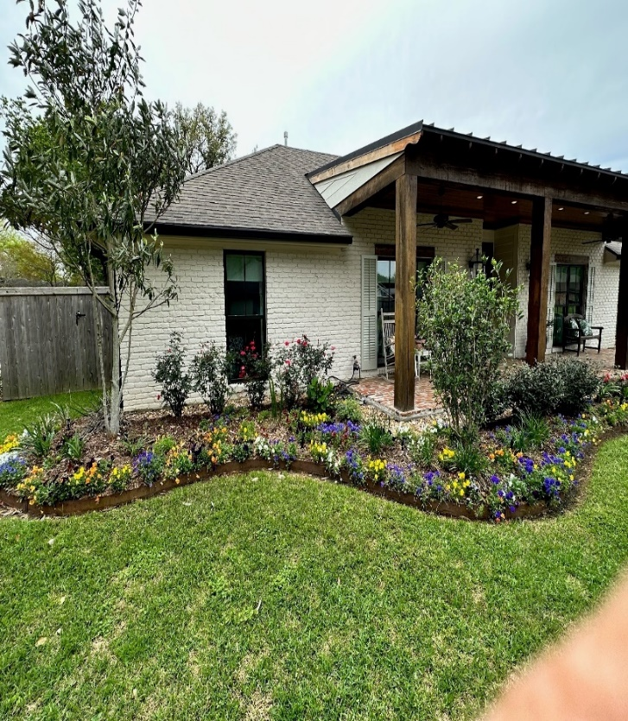
LGC April 2023 Civic Pride Award
The Lafayette Garden Club is pleased to announce the April 2023 Civic Pride award to Summer Place Apartments located on 1901 Eraste Landry road in Lafayette, Louisiana. Standing next to the Civic Pride sign is Sandy the General Manager. The apartment is beautifully landscaped with loads of Pansies, Fox Tail Ferns, Sweet Olive trees, and Camellias. A large pot is filled with purple Oxalis and the lawn is lush and perfectly manicured. Lastly, the best part is driving up to the apartments and seeing the American 🇺🇸 and the UL flag.
Thank you, Sandy, for keeping Lafayette beautiful.
Lafayette Garden Club is a member of District III, Louisiana Garden Club Federation, Inc, Deep South Garden Clubs, Inc, and the National Garden Club Federation, Inc.
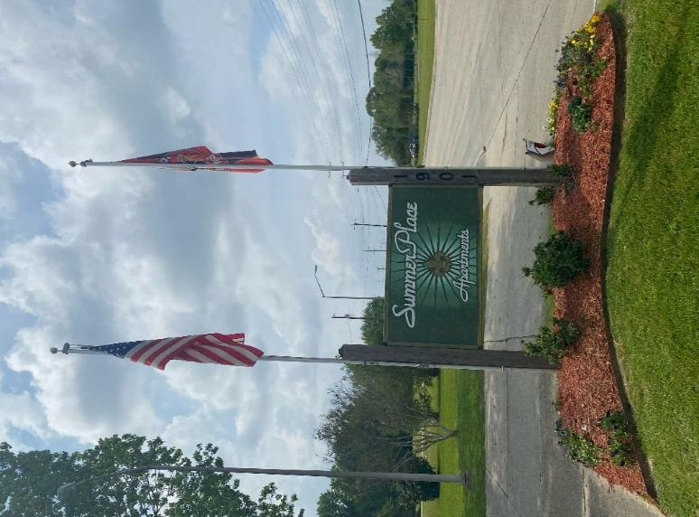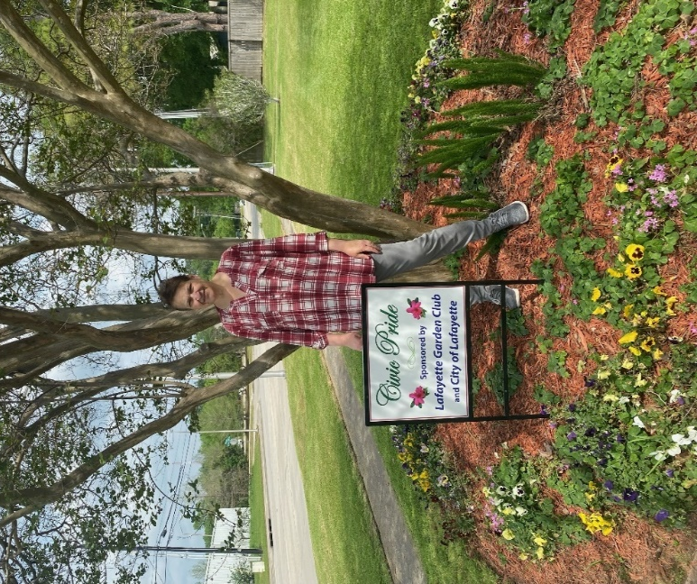
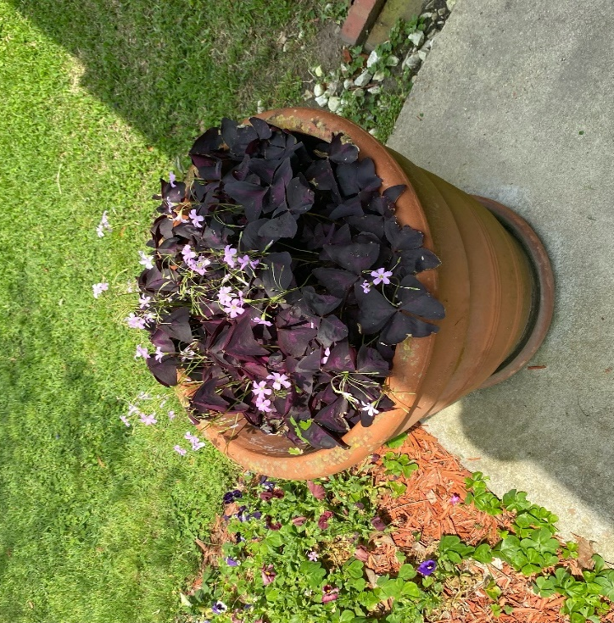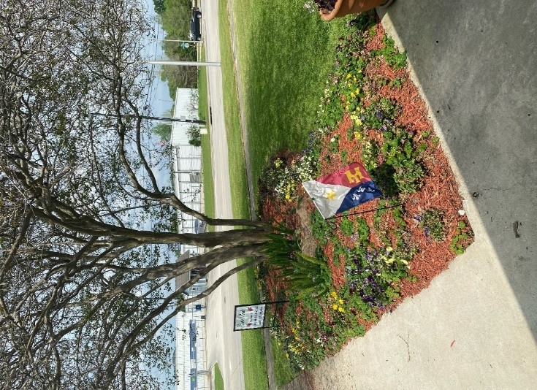

Lafayette Parish Cleanest School Awards April 2023
The winners of the Cleanest Schools were announced! Because of the volume of schools judged and difficulty in taking pictures of some schools, pictures are not available.

ELEMENTARY SCHOOL WINNERS:
1st. Green T. Lindon Elementary
2nd. Katharine Drexel Elementary
3rd. Ossun Elementary

MIDDLE SCHOOL WINNERS
1ST. Milton Middle School
2nd. Edgar Martin Middle School
3rd. Judice Middle School

HIGH SCHOOL WINNERS:
1ST. Lafayette High School
2nd. Acadiana High School
3rd. Comeaux High School

Lafayette Garden Club is a member of District III, Louisiana Garden Club Federation, Inc, Deep South Garden Clubs, Inc, and the National Garden Club Federation, Inc.

Lafayette Garden Club New Award Cleanest School
Many are not aware of the difficulty in judging all of the schools. They are located in all of cities of the Parish, many in small, isolated communities that require out of the way driving.
Our new award “The Car 54 Where Are You” is a tie this year! Below are the participants!
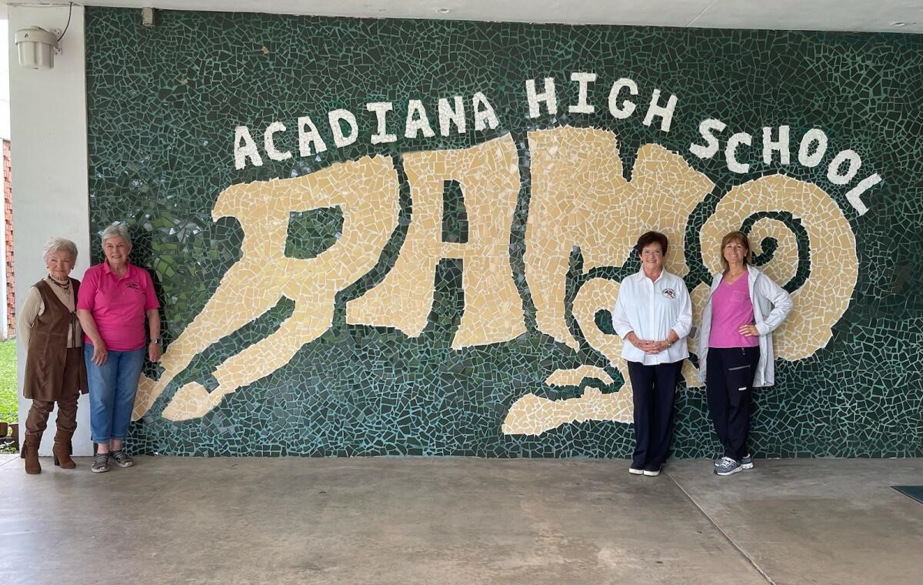
Judging Acadiana High School are Betty Foret, Sarah Schoeffler (Driver), Becki Lege, Veronica DuBose
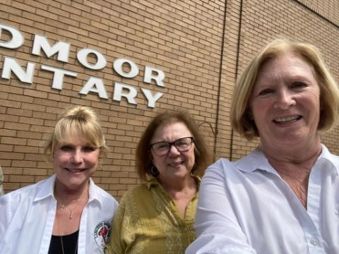
At Broadmoor Elementary are judges Roxanna Champagne, Debbie Grissom and Linda Beyt (Driver).
Lafayette Garden Club is a member of District III, Louisiana Garden Club Federation, Inc, Deep South Garden Clubs, Inc, and the National Garden Club Federation, Inc.

Brownie/Girl Scout Planting
Fourteen of seventeen Brownies of Troop 1214 participated in two old flower bed refurbishing on Saturday, April 1, 2023 at Our Lady of Fatima. School.
The work was to beautify the school and teach the girls gardening skills in the process Two scouts stated that before today they didn’t think gardening was fun but now plan to help in the future. A success, for sure! Troop participants include: Catherine Comeaux Project Coordinator, Kathi Kane Troop Leader, Melanie Schoeffler Tanya Cane Brownie Mother. LGC members include: Anita Petitjean (President), Sarah Schoeffler, Becky Lege, Linda Beyt, Kathy Van Ness.

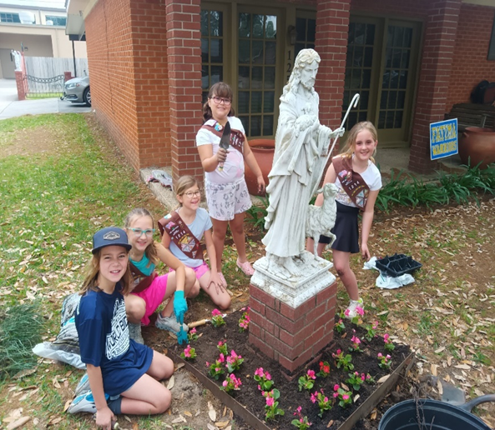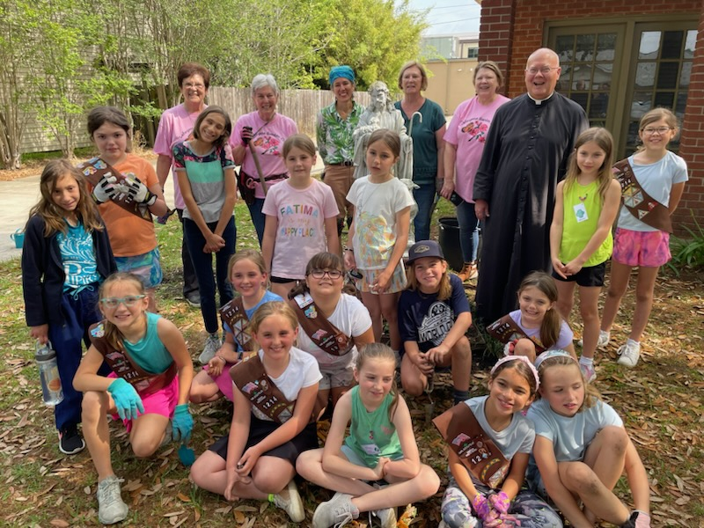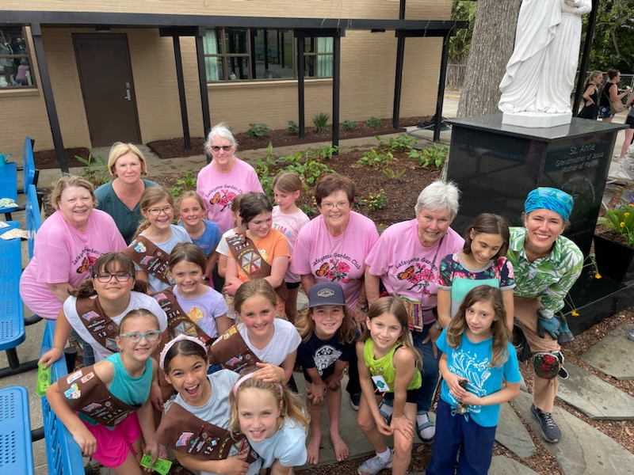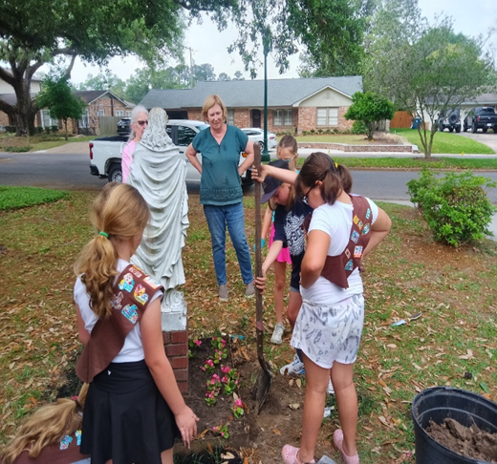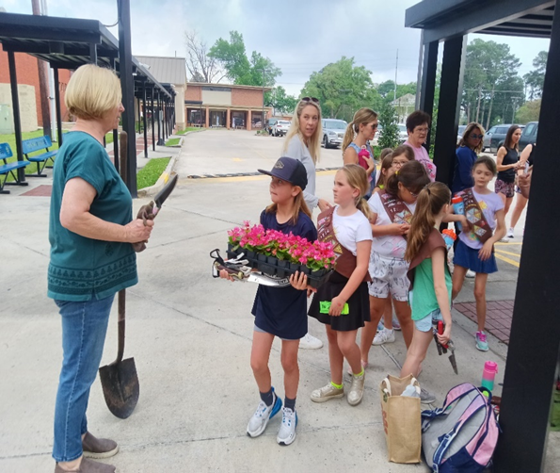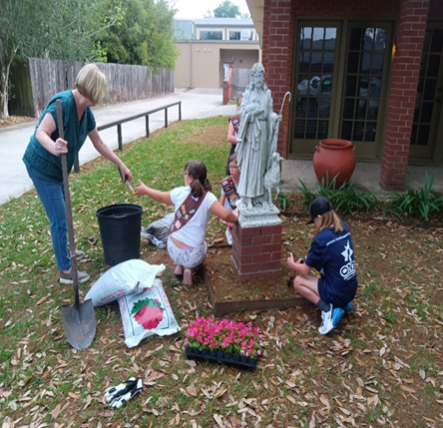
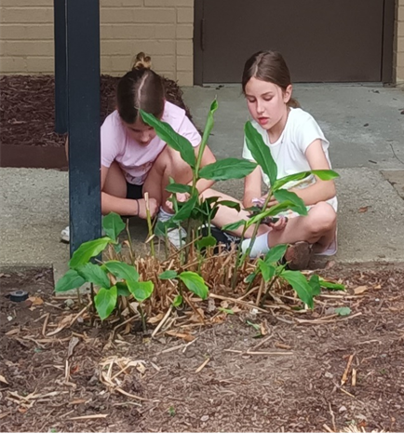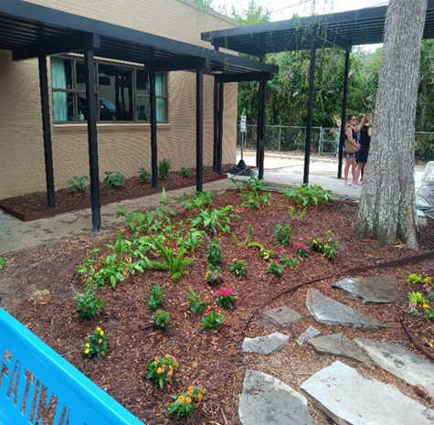
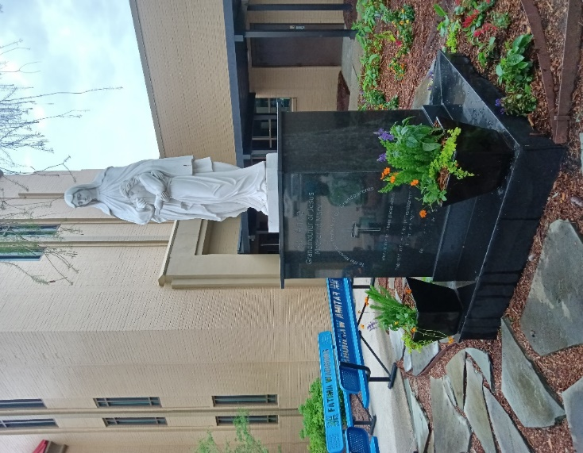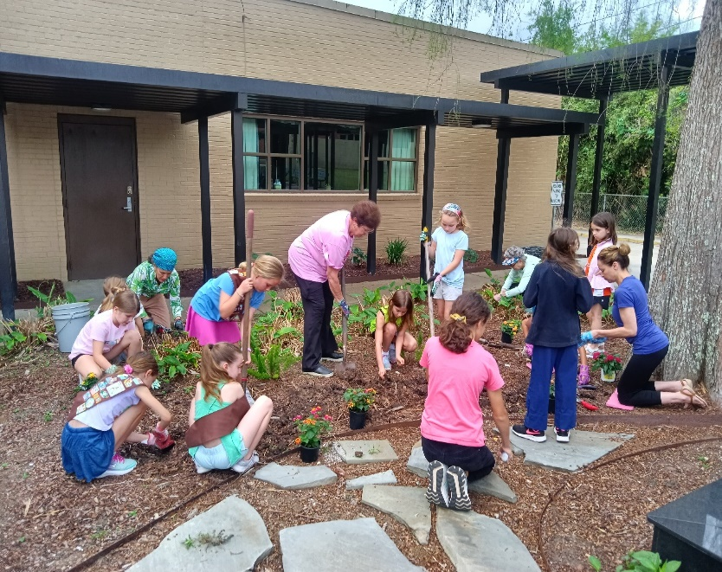
Lafayette Garden Club is a member of District III, Louisiana Garden Club Federation, Inc, Deep South Garden Clubs, Inc, and the National Garden Club Federation, Inc.

Festival de Fleurs Television Advertisement
On April 10th, 2023, Babette Werner, member of Lafayette Garden Club discussed Festival on KADN Channel 15 noon report. Babette (left) discussed the festival with Anchor, Taylor Trachete.
Lafayette Garden Club is a member of District III, Louisiana Garden Club Federation, Inc, Deep South Garden Clubs, Inc, and the National Garden Club Federation, Inc.

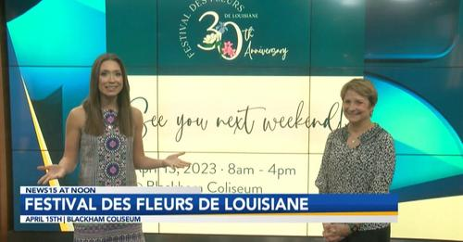
Bayou Vermilion Preservation Association
March 31, 2023, BVPA met at the Lite Center in Lafayette met for a symposium. LGC is a sponsor of BVPA. Babette Werner of LGC was awarded the “Visionary of the Year”. Lafayette Garden Club founded Bayou Vermillion Preservation Association as part of a National Garden Club project, “Protecting Aquatic Ecosystems”. Babette Werner was a founding member and became chairman of “Protecting Aquatic Ecosystems after Jan moved to Florida.
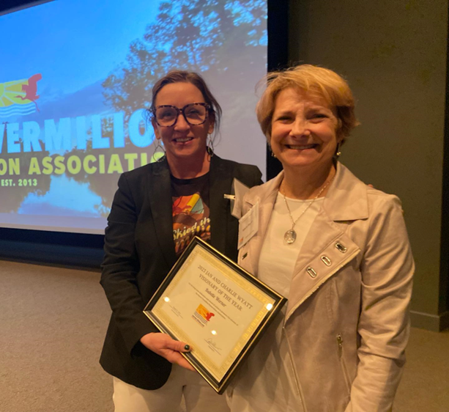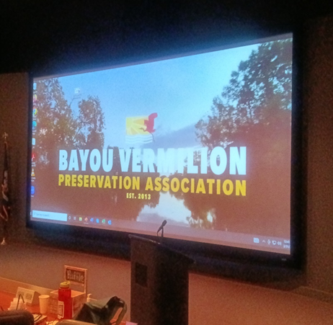

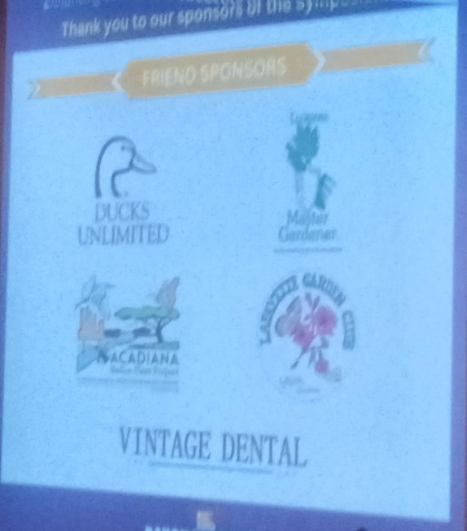
Lafayette Garden Club is a member of District III, Louisiana Garden Club Federation, Inc, Deep South Garden Clubs, Inc, and the National Garden Club Federation, Inc.
Festival de Fleurs de Louisiana
And Lafayette Garden Club’s NGC Small Standard Flower Show
On 15 April 2023, Festival de Fleurs de Louisiane and the Flower Show was held at Blackham Coliseum. Lafayette Garden Club is a proud sponsor of Festival de Fleurs de Louisiane. The theme of the Flower Show was “Literary Allusions.”

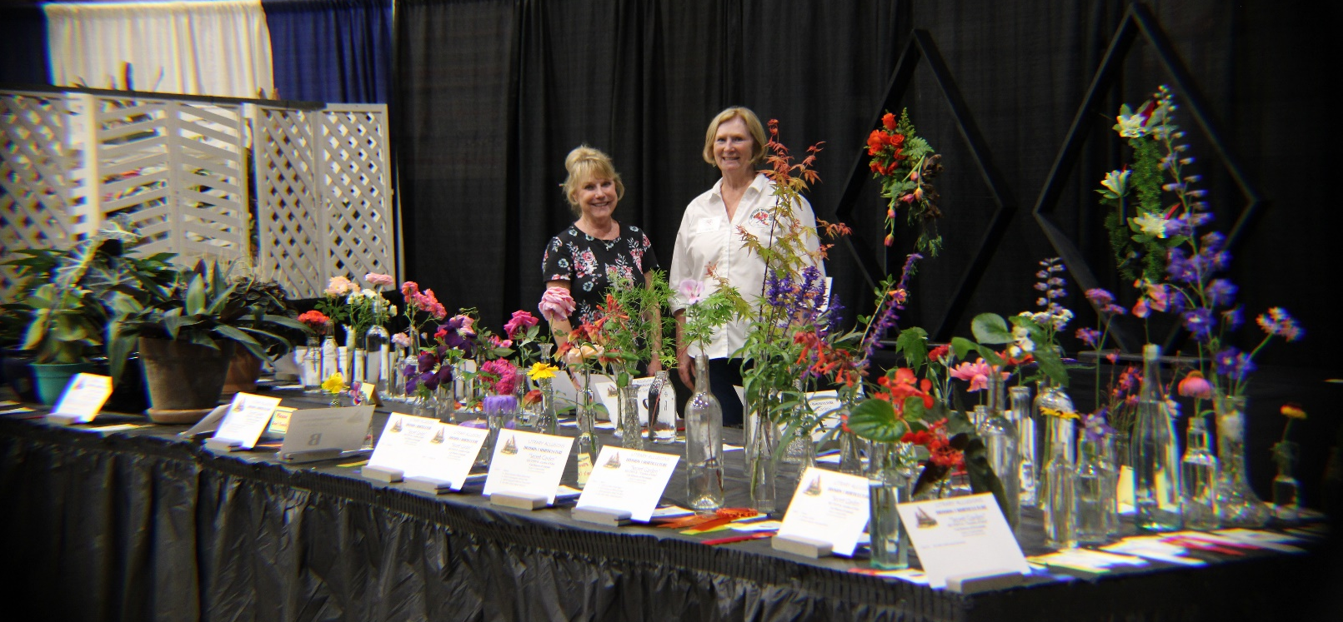
Standing behind an array of colorful flowers and plants are Roxanna Champagne, Louisiana Garden Club Federation President and Linda Beyt, Lafayette Garden Club President-elect.

Division I – Horticulture
“Secret Gardens”
Top Horticulture Exhibitor Award Winners
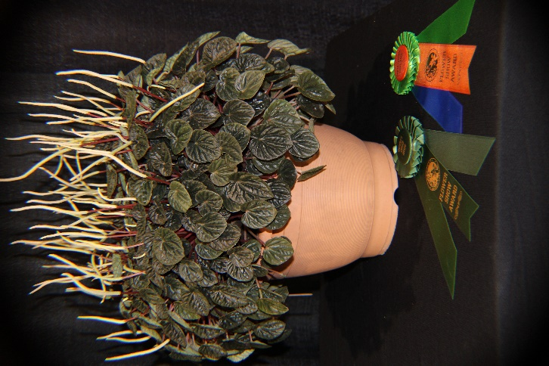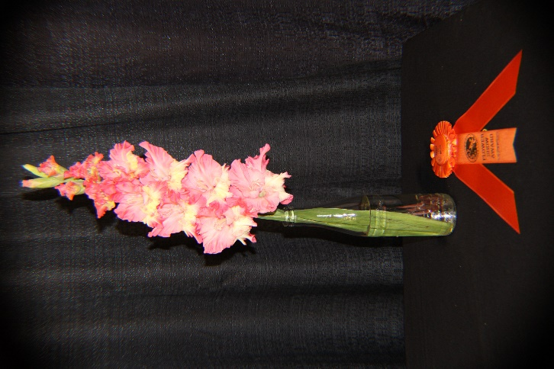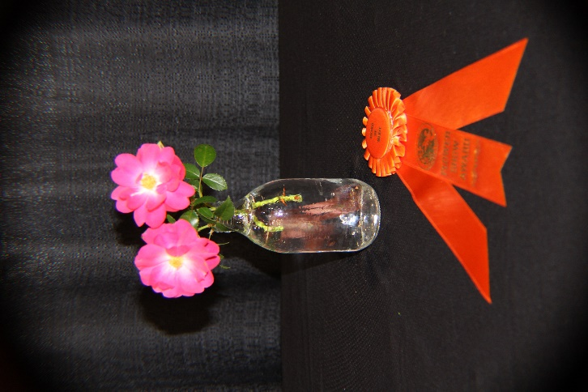
Becky Latiolais’ Peperomia argyreia Denise Lanclos’ Gladiolus received Becky Lege’s Rosa received an
Received the Growers Choice Award an Award of Merit Award of Merit
And Horticulture Excellence Award
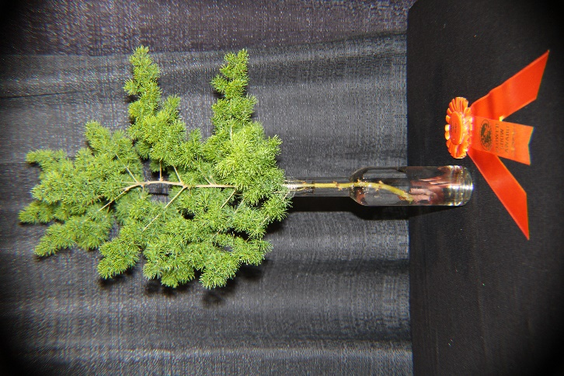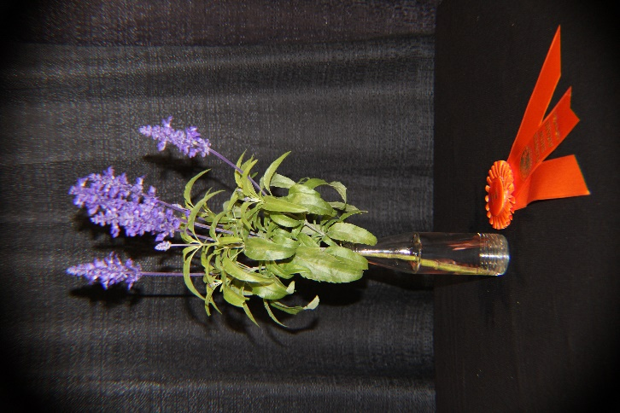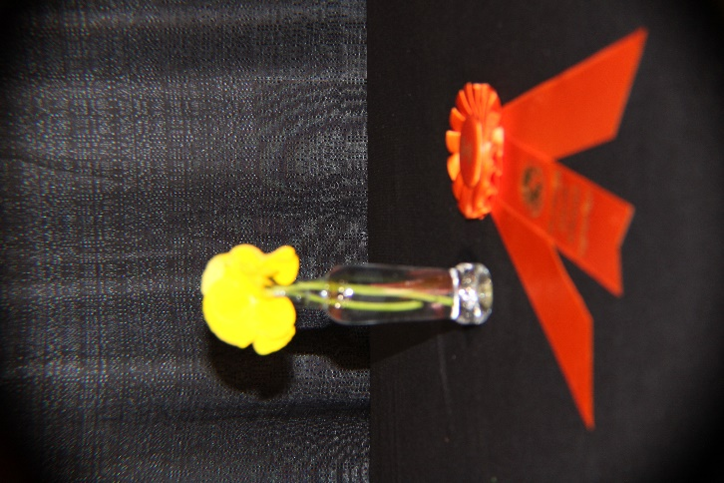
Left to right: Asparagus densiflorus (ming fern), Salvia farinacea (Mealy cup sage) and Viola x wittrockiana (Pansy) entered by Roxanna Champagne won Awards of Merit.
Also winning an Award of Merit, but not pictured was May Vidacovich’ s Acer x pseudosieboldianum “First Flame’.
The Sweepstakes Award given to the exhibitor who won the most Blue Ribbons was won by Becky Lege. A total of 99 horticulture exhibits were entered in the Flower Show with thirteen Lafayette Garden Club members entering horticulture and one member from Azalea Garden Club.
Division II Design
“Chloris”
Section A “Characters”
Class 1 – “Peter Pan” Framed Spatial Design
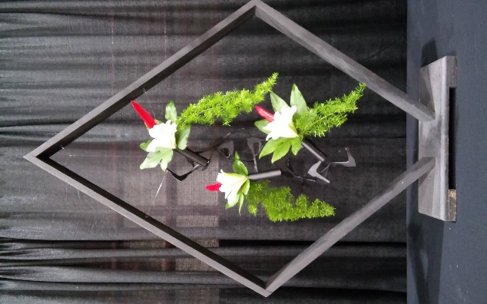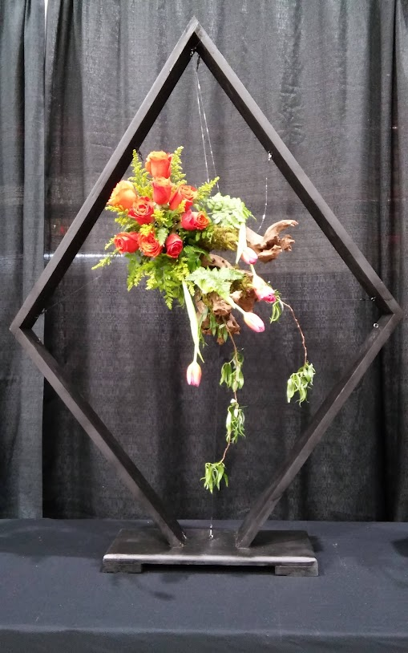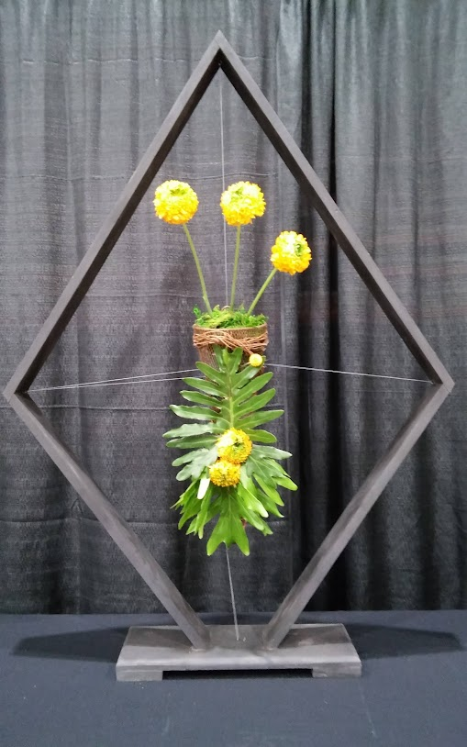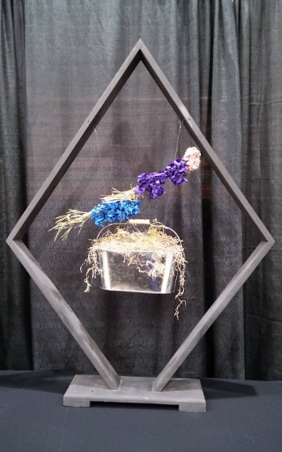
Left to right: First Place and the Award of Design Excellence was won by Roxanna Champagne. Donna Augustine’s design placed second, Cynthia Risinger-Johnson’s design received third place and Margaret Melancon’s design received Honorable Mention.
Class 2 – “Joseph’s Coat of Many Colors” Tapestry Design
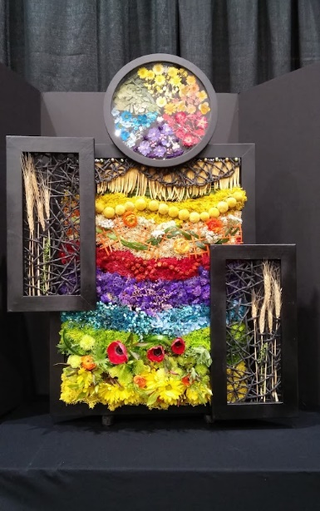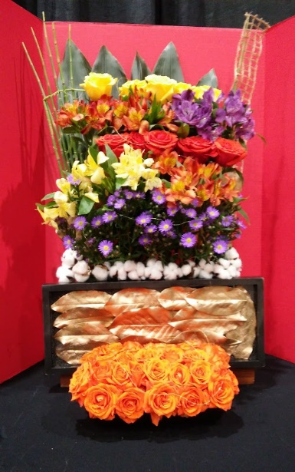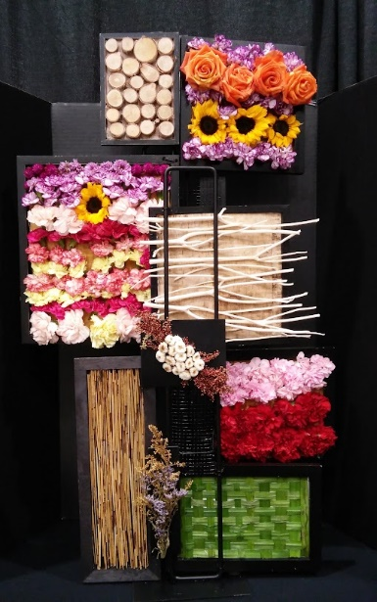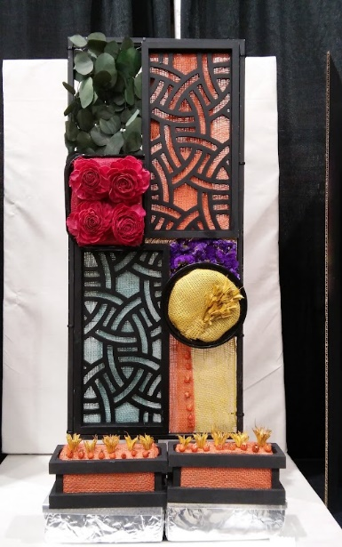
Left to right: Noreen Bienvenu’s design received first place, Angel Landry’s Design placed second, Versa Dore’s design placed second and Karen Hoyt’s design received Honorable Mention. Noreen Bienvenu’s design was the winner of the People’s Choice Award, which was open to the public to choose their favorite design.
Class 3 “March Sisters” Parallel Design
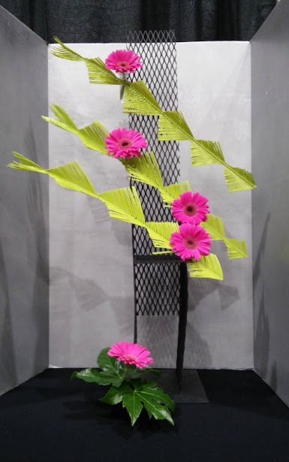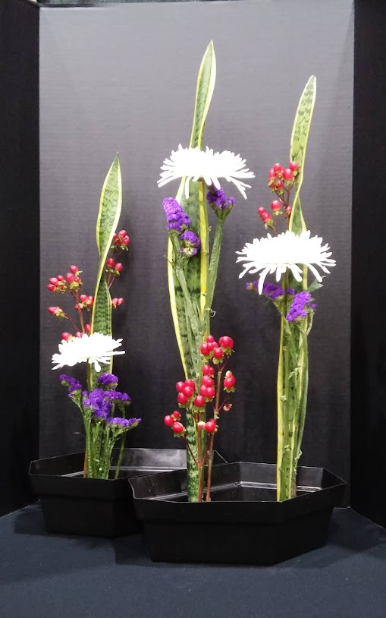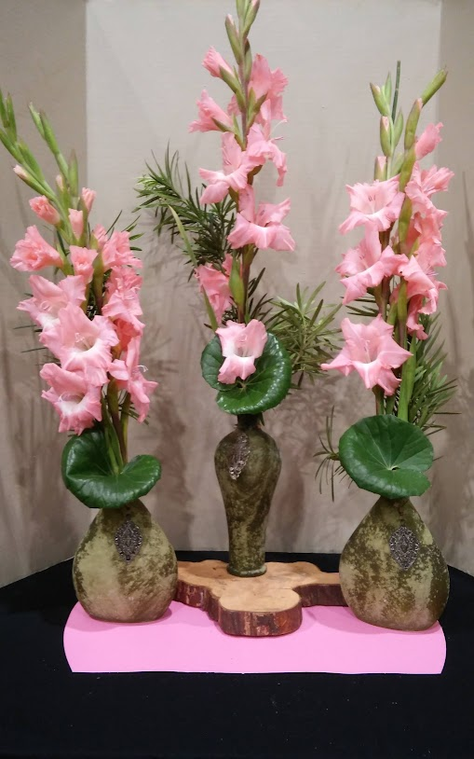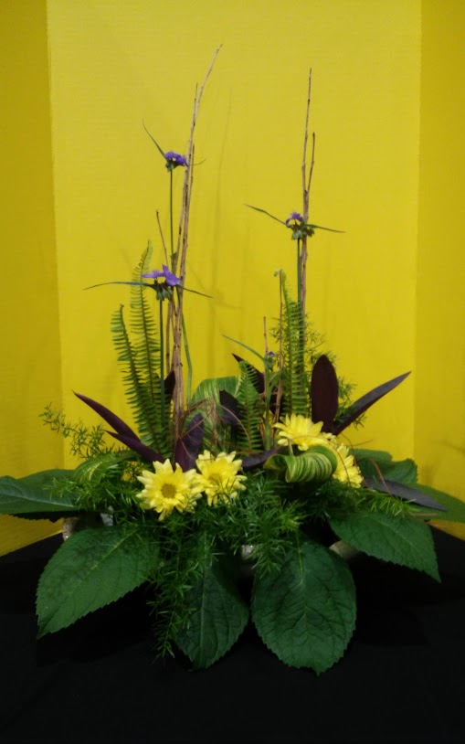
Left to right: Loraine Allain’s design received first place, Jeanie Richard’s design placed second, Betty Foret’s design placed third and Marsha Trahan’s design received Honorable Mention.
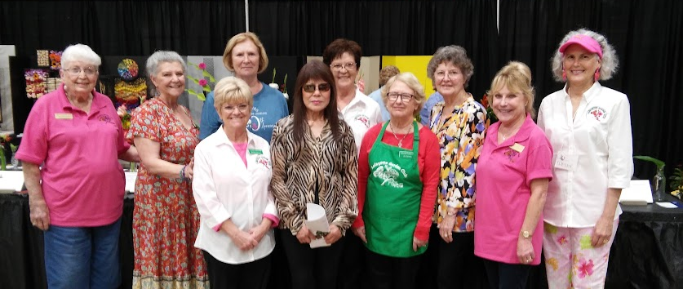
Above are members of the Lafayette Garden Club who won at least one Blue Ribbon in Horticulture.
Members above all participated in the Flower Show through entering horticulture, designs, helped with staging, served as clerks for the judges and/or served as hostesses during the Flower Show. Without their participation, there would not have been a Flower Show. Thank you!!!
Lafayette Garden Club is a member of District III, Louisiana Garden Club Federation, Inc, Deep South Garden Clubs, Inc, and the National Garden Club Federation, Inc.
LGC April Field Trip
On 12 April 2023 the club made a field trip to Colette Anzalone’s Nature Floral Flower Farm in Brossard, Louisiana. Colette explained to members how she began growing cut flowers and the details involved in growing cut flowers. Members toured the cut flower beds, processing barn and cooler used for storing and keeping the flowers fresh. Colette generously shared seeds, cut flowers and plants with the garden club members. After the tour, members enjoyed lunch at a nearby restaurant.
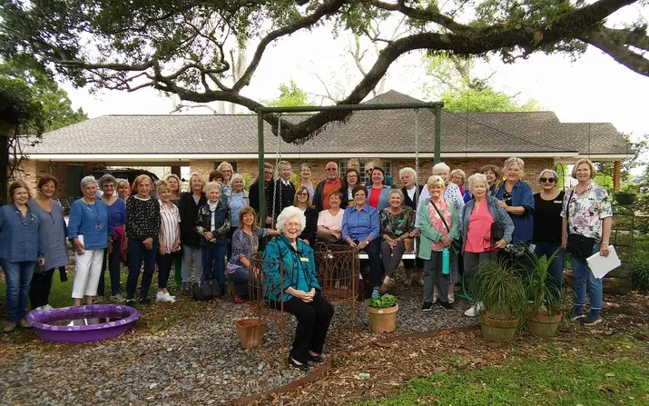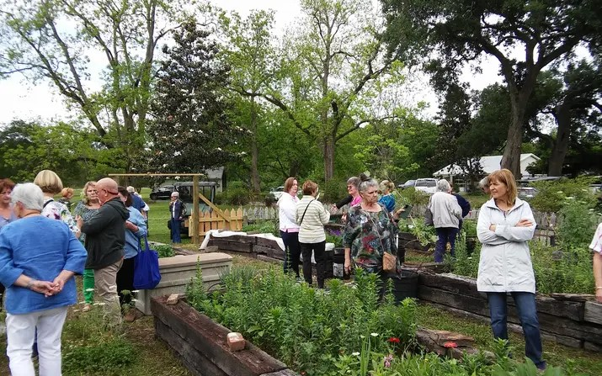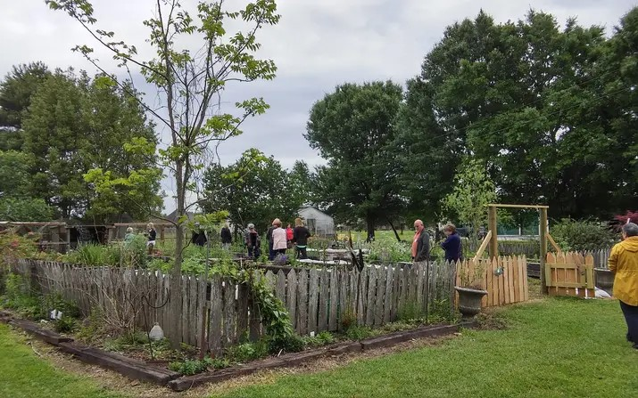
Above, members touring the cut flower beds. Below lovely flowers and buckets of cut flowers.
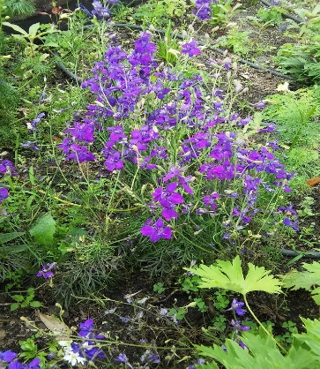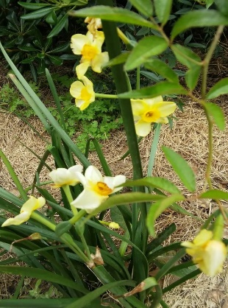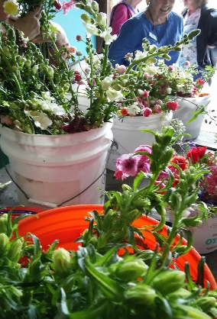
Lafayette Garden Club is a member of District III, Louisiana Garden Club Federation, Inc, Deep South Garden Clubs, Inc, and the National Garden Club Federation, Inc.
Louisiana Garden Club Federation State Convention
Held in Vidalia, Louisiana in April 17-20th the LGCF Convention featured the Installation of the 2023-205 LGCF Officers, Executive Council Meeting, Board of Directors Meeting, the Awards Banquet and School Council Meetings. Informative and interesting workshops were held on various topics as well as a Design Luncheon featuring Alan Futch, the Dean of Flowers.
Louisiana Garden Club Federated, Inc. Awards: Deep South Garden Clubs, Inc. Awards:
#34 Special Social Media 1st Place #31 DSGC Yearbook HM (70-99 members)
#24 Billie Massa Liter Control 1st Place #27 A Small Standard Flower Show Schedule 1st Place ($50)
#22 Publicity Press Book Large Club 1st Place #17 Community Action Large Club 3rd Place
#19 Willie Hundley PR 1st Place #6 Bird Award Large Club 3rd Place
#18 Vickie Lacombe Bird 1st Place #5 Litter Control 1st Place Large Club ($25)
#2-5 Yearbook 1st Place #3Public Relations 1st Place Large Club
#9A Small Standard Flower Show Schedule 1st Place
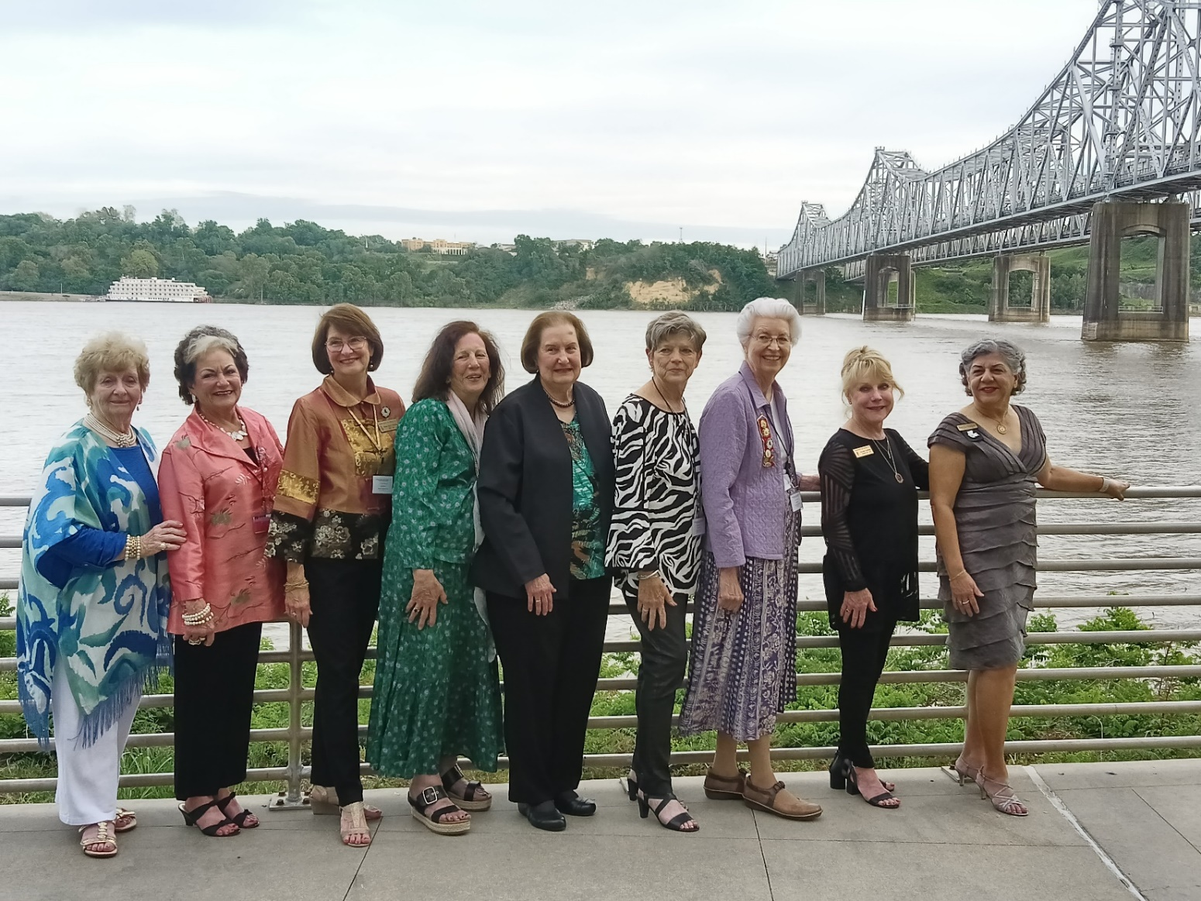
Pictured above (left to righ)t are LGCF Former State Presidents: Mary Sue Colvin, Margo Racca, Donna Bucci, Mary Jacobs, Yvette Hebert, Lena Bateman, Linda Finley, Immediate Past President Roxanna Champagne and 2023-2025 President Patricia Ortalano are pictured with the Mississippi River in the background.
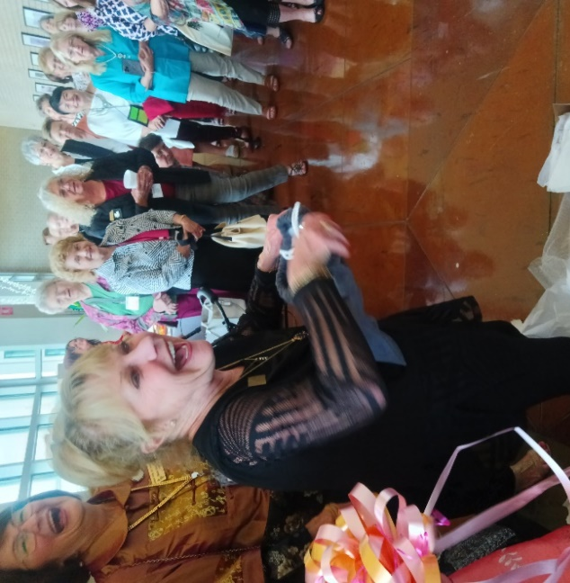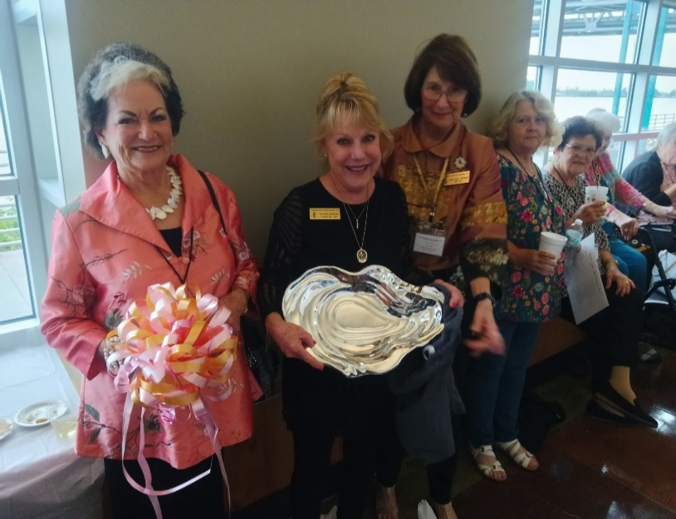
Outgoing LGCF President Roxanna Champagne is seen above enjoying her reception sponsored by the Convention. In the second photo are Margo Racca, Former LGCF President, Roxanna holding are gift from her fellow officers, and Donna Bucci, Former LGCF President from District III.

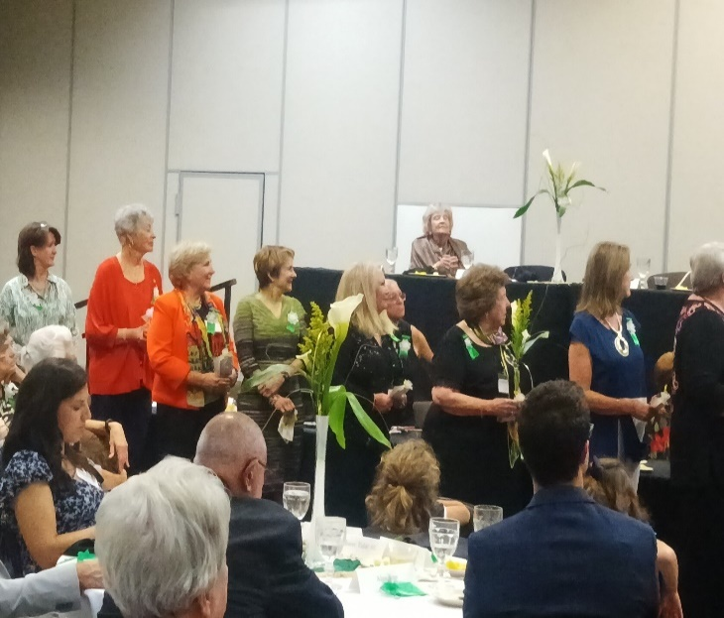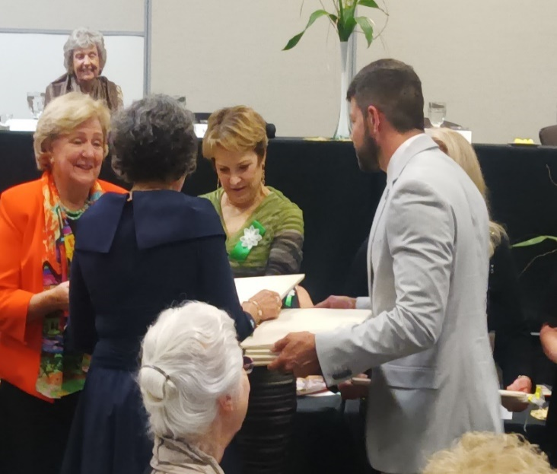
2023-2025 LGCF Officers are being installed along with Babette Werner, incoming District III Director.
Lafayette Garden Club is a member of District III, Louisiana Garden Club Federation, Inc, Deep South Garden Clubs, Inc, and the National Garden Club Federation, Inc.

City of Lafayette Trash Bash
On April 22, 2023, members of LGC provided support to the City of Lafayette on Trash Bash Day. Members assisted in providing refreshments to individuals picking up the trash.
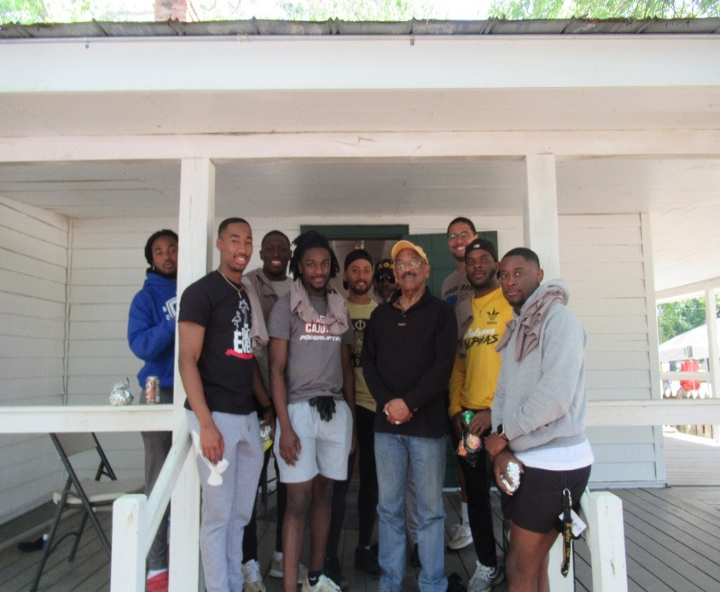

A big shout out to this group of young men from the Alpha Phi Alpha, chapter Zeta Xi from ULL who volunteered on a Saturday morning to provide muscle in getting things done. Much would not have been accomplished without their valued assistance!
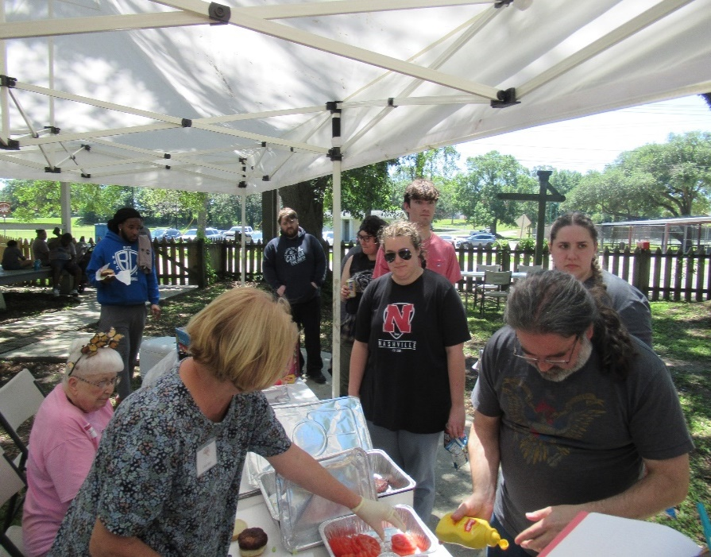
Nothing like a little lunch after a hard morning’s work! Lafayette Garden Club members Diana Nolan and Linda Beyt are seen serving food to hungry volunteers.
Lafayette Garden Club is a member of District III, Louisiana Garden Club Federation, Inc, Deep South Garden Clubs, Inc, and the National Garden Club Federation, Inc.

Lafayette Cleanest City Poster Winners
On 4 April 2023, winners of the Litter Poster Contest were announced and were presented their awards at Lafayette Public Library South. Below are the winning posters from elementary, middle school and high school students throughout Lafayette Parish.
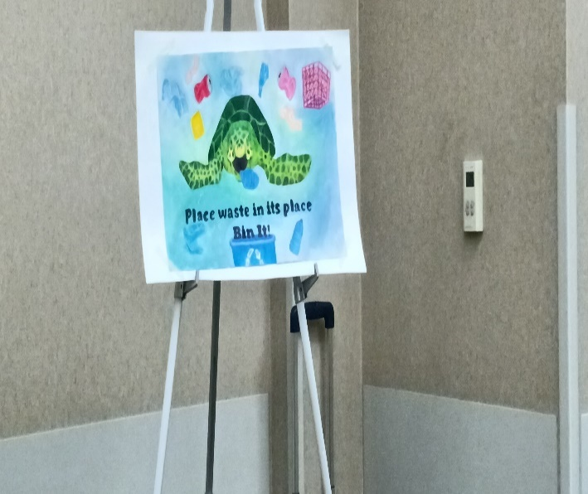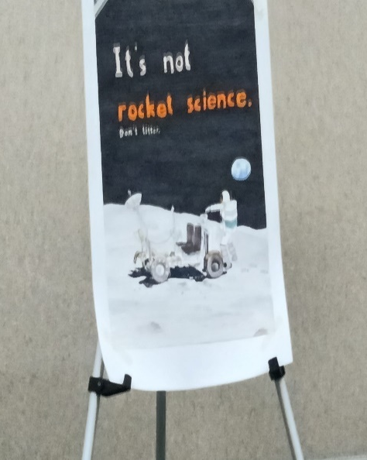
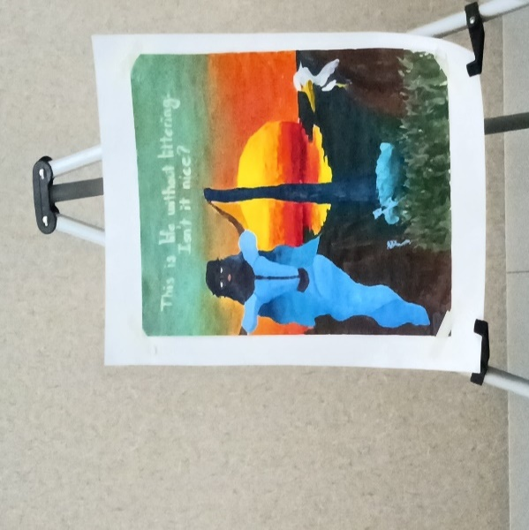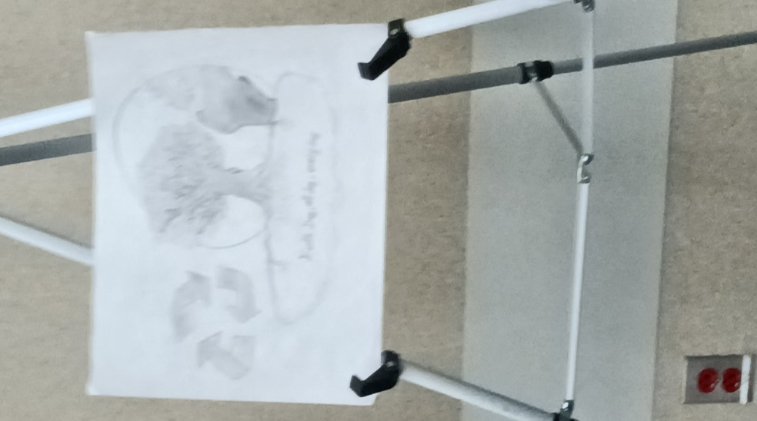
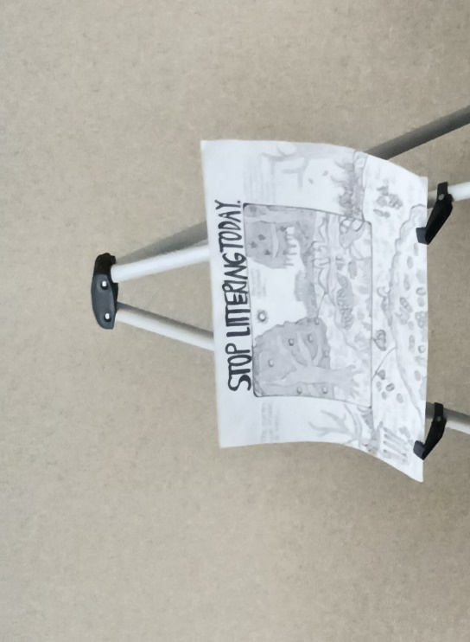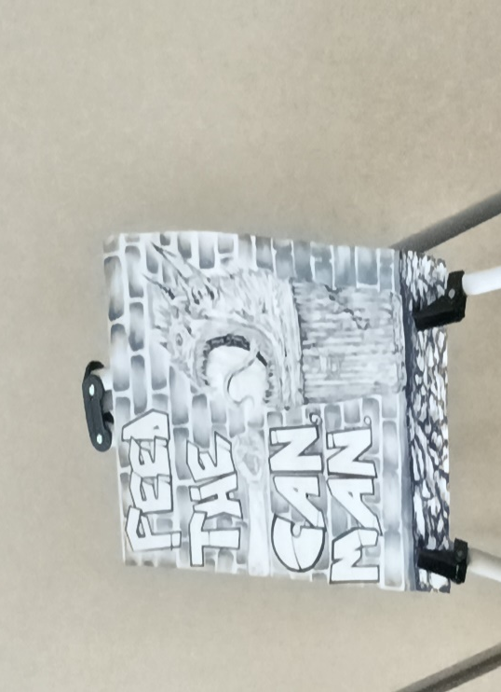
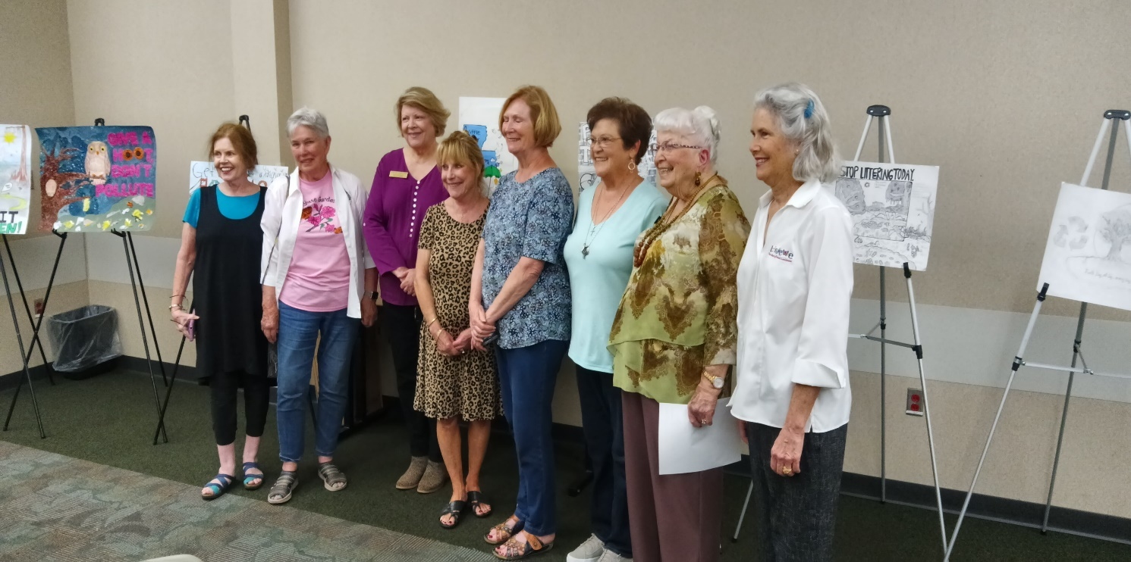
Lafayette Garden Club members in attendance at the awards presentation are Cecille Revels, Sarah Schoeffler, President Anita Petitjean, LGCF President Roxanna Champagne, Linda Beyt, Becky Lege, Cleanest City Chairman Diana Nolan and Denise Lanclos.
Lafayette Garden Club is a member of District III, Louisiana Garden Club Federation, Inc, Deep South Garden Clubs, Inc, and the National Garden Club Federation, Inc.
Biedenharn Garden Symposium
A small group of Lafayette Garden Club members met in Monroe Louisiana at the Biedenharn Museum for a symposium 0n 21 April 2023, following the Convention in Vidalia. While Colonel Pemberton is credited with developing the formula for Coca Cola, it is the Biedenharn Family that first bottled the product. The programs consisted of Camelia discussions, flower presentation and Eudora Welty Garden discussion.
